

**Awns’s shop**

**(Laptop & Phone)**

**Software Requirement Specification**

**Team 1**

– Hanoi, February 2023 –

Record of changeS

|  |  |  |  |
| --- | --- | --- | --- |
| Date | A* M, D | In charge | Change Description |
| 7/2 | A | GiangNXT | Add screen flow (I.2.a) |
| 8/2 | A | GiangNXT | Add introduction (I.1), screen details (I.2.b), User Authorization (I.2.c) |
| 10/2 | M | GiangNXT | Update screen flow (I.2.a), screen details (I.2.b) |
| 15/2 | A | GiangNXT | Add entity requirement diagram (I.3) |
| 17/2 | M | GiangNXT | Update Functional Requirement (II.2), screen flow (I.2.a) |
| 3/3 | M | GiangNXT | Update Functional Requirement (II.2.e) |
| 3/3 | A | GiangNXT | Add Functional Requirement (II.3, II.4, II.5) |
| 15/3 | A | GiangNXT |  |
|  |  |  |  |
|  |  |  |  |
|  |  |  |  |
|  |  |  |  |

*A - Added M - Modified D - Deleted

**Table of Contents**

I. Overview 6

1. Introduction 6

2. System Functions 7

3. Entity Relationship Diagram 9

II. Functional Requirements 10

1. Public Feature 10

a. Home Page 10

b. Products List 11

c. Product Details 12

d. Check the order 13

e. My Cart 14

f. Payment Page 14

2. Common Feature 15

a. User Login 15

b. User Profile 16

c. My Orders 17

d. Order Information 17

e. Employee Login 18

3. Admin Feature 19

a. Admin Dashboard 19

b. Employee Management 19

4. Warehouse Feature 21

5. Sale Feature 21

a. Sale Dashboard 21

b. Product Management 21

# I. Overview

## 1. Introduction

The shopping online system is an e-commerce platform that allows users to purchase products (phone or laptop). The system will be used in a web-based environment and is accessible through a desktop or mobile device with an internet connection. The users of the system are customers who are looking to purchase products.

Constraints for the system include the requirement for accurate product information and inventory management. Assumptions for the system include a stable internet connection and a functional web browser. Dependencies for the system include a database to store customer information and purchase history.

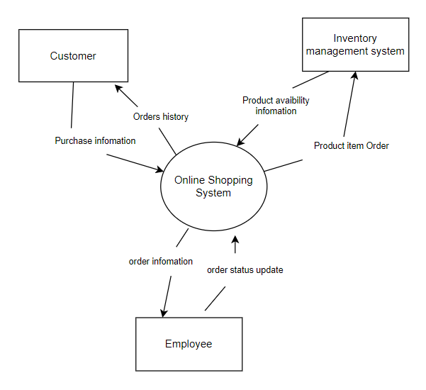

## 2. System Functions

#### a. Screen Flow

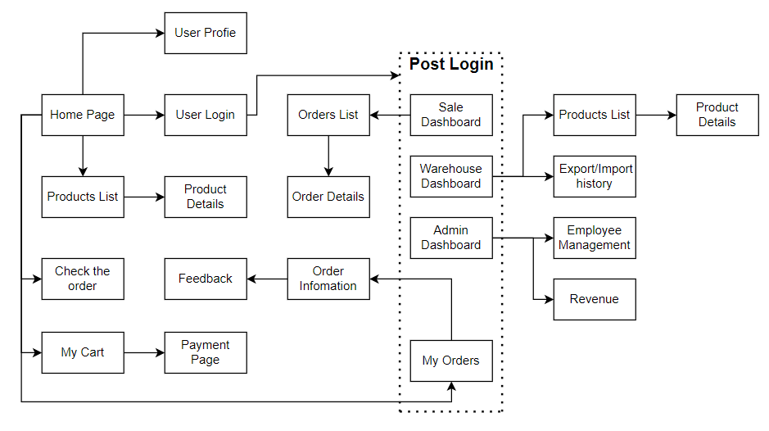

#### b. Screen Details

|  |  |  |  |
| --- | --- | --- | --- |
| **#** | **Feature** | **Screen** | **Description** |
| 1 | Public | Home Page | - Show navigation bar: product search box, product categories (phone or laptop), cart - Shown featured products, promotional product, product list (phone and laptop) - Shown product information includes its thumbnail, title, brief information; the user is redirected to the product's details on his/her clicking |
| 2 | Public | Products List | - Show navigation bar: product search box, product categories (phone or laptop), cart  - Show the products paginated (sorted by updated date)  - Shown product information includes its thumbnail, title, brief information, original price, and sale price;  - The user can: sort list by promotional, increasing price, decreasing price and filter product  - The user is redirected to the product's details on his/her clicking on the product |
| 3 | Public | Product Details | - Show navigation bar: product search box, product categories (phone or laptop), cart  - Show product details (including title, category, images, original price, sale price, and detail information) |
| 4 | Public | Check the Order | - Show navigation bar: product search box, product categories (phone or laptop), cart  - The user can search order information by bill of landing code |
| 5 | Public | My Cart | - Show navigation bar: product search box, product categories (phone or laptop), cart  - Show the cart details with list of the user's chosen products (including Id, title, price, quantity, total cost) and the total order price  -The user can:  + Change the quantity of each product: the total cost is automatically adjusted  + Choose to delete/remove product by clicking on the deleting icon  + Click the Remove All to remove all product in cart  + Click the Continue Shopping button to go to Products List page  + Click the Check Out button to go to the Cart Contact page Please notes: the user's chosen products from the last browsing session are remained in his/her cart until s/he submit the cart. However, the product prices are updated with the latest prices in the system |
| 6 | Public | Payment Page | - Show navigation bar: product search box, product categories (phone or laptop), cart  - Show the list of user’s chosen product (including id, title, price, quantity, total cost), the total order price and the receiver information (including full-name, email, mobile, address, notes, payment method) for user to edit/input  - In case the user has logged in, the receiver information would be filled with the user's information  - The user can click the My Cart button to come back to the My Cart page for changing the choosing products, click the Submit button to submit the order. |
| 7 | Common | User Login | This screen allows the user to login with email, after login user redirect to Home page |
| 8 | Common | User Profile | This screen allows the user to edit his/her profile information (including full-name, email, mobile, address). |
| 9 | Common | My Orders | - Show navigation bar: product search box, product categories (phone or laptop), cart  - Show the list of user's orders paginated - Each order include below information: id, ordered date, order status, total cost, order information link; - On clicking the order information link, user would be redirected to the Order Information page |
| 10 | Common | Order Information | - Show navigation bar: product search box, product categories (phone or laptop), cart  - Show the order details, including the information as below - The order id, order date, total cost, status - The receiver information: full name, email, mobile - This list of ordered products, each product include following information & the links/buttons that allow the user to re-buy: thumbnail, name, category, unit price, quantity, total cost  For the submitted orders, the user can cancel the order |
| 11 | Common | Employee Login | - Show textbox username and password to input  - Login button to submit username and password and login to system |
| 12 | Admin | Admin Dashboard | - Show menu bar to navigate to other functions/screens  - Show revenue chart (30days/month/year)  - Log out button to log out system |
| 13 | Admin | Employee Management | - Show list of employees  - The admin can create new employee account, view, edit employee information, delete employee account |
| 14 | Sale | Sale Dashboard | - Show menu bar to navigate to other functions/screens  - Show related – sale data  - Log out button to log out system |
| 15 | Sale | Product Management | - Show list of product and product detail information  - The sale can search product, view, edit product information, create new product, delete product |

#### c. User Authorization

|  |  |  |  |  |  |
| --- | --- | --- | --- | --- | --- |
| **Screen** | **Guest** | **Customer** | **Sale** | **Warehouse Manager** | **Admin** |
| Home Page | X | X |  |  |  |
| Products List | X | X |  |  |  |
| Product Details | X | X |  |  |  |
| Check the Order | X | X |  |  |  |
| My Cart | X | X |  |  |  |
| Payment Page | X | X |  |  |  |
| User Login |  | X | X | X | X |
| User Profile |  | X |  |  |  |
| My Orders |  | X |  |  |  |
| Order information |  | X |  |  |  |
| Employee Login |  |  | X | X | X |
| Admin Dashboard |  |  |  |  | X |
| Employee Management |  |  |  |  | X |
| Sale Dashboard |  |  | X |  |  |
| Product Management |  |  | X |  |  |

In which:

* Guest: unregister user
* Customer: customers or potential customers
* Sale: the sale members of the organization
* Warehouse Manager: the warehouse manager in the organization
* Admin: the organization leader/manager, acts as the system administrator

#### d. Non-Screen Functions

|  |  |  |  |
| --- | --- | --- | --- |
| **#** | **Feature** | **System Function** | **Description** |
| 1 | Common | User Authorization | Implementation of authorization mechanism in the system, including the specify the role of logged-in user, his/her authorized page links (building the displayed menu items (in the front end) and preventing unauthorized access via enter the links directly) |

## 3. Entity Relationship Diagram

# II. Functional Requirements

## 1. Public Feature

### a. Home Page

* Function trigger: The page shows up when users access the web application
* Function description: The user can view lists of products
* Screen layout:

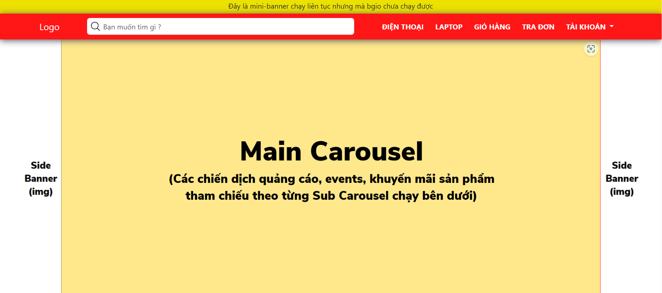

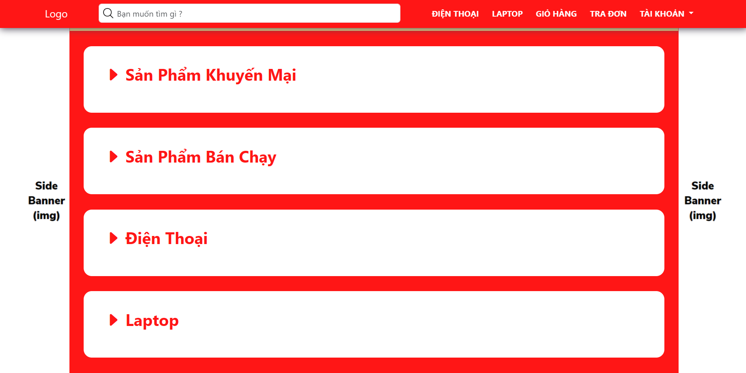

* Function Details:
  + Components to link to the other functions
  + This screen includes navigation bar (product search box, product categories (phone or laptop), cart) and lists of products (featured products, promotional product, phone list, laptop list)

### b. Products List

* Function trigger: When user click on “Điện thoại” or “Laptop” button on navigation bar
* Function description: The purpose of this function is to show all available products with the product's category (Phone or Laptop) on the website
* Screen layout:

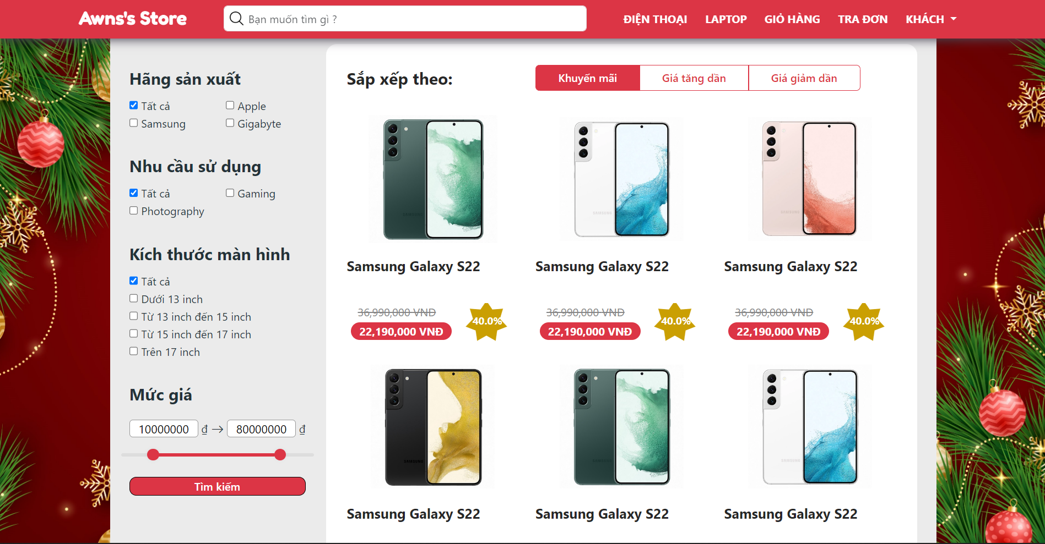

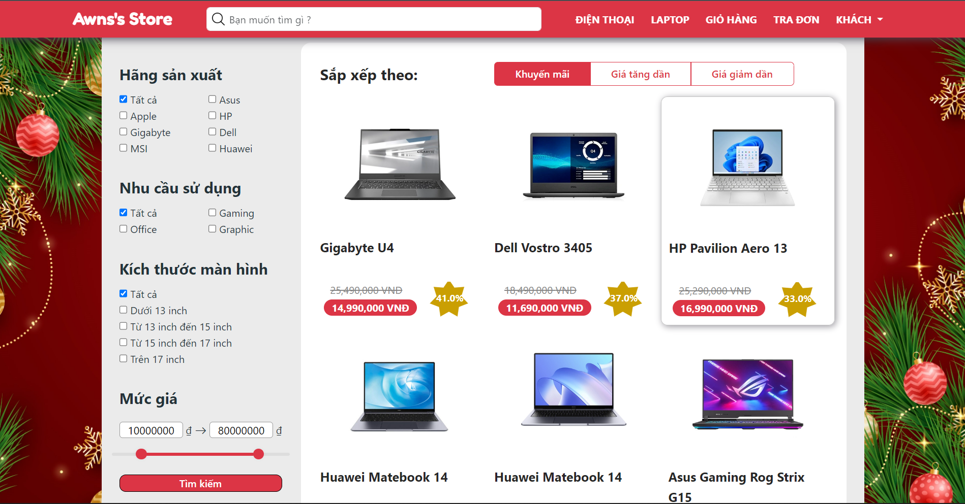

* Function Details:
  + Show all products paginated (sorted by update date)
  + Filter product by each category corresponding to the product
  + Sorting products by price
  + The user is redirected to the product's details on his/her clicking on the product

### c. Product Details

* Function trigger: This function will be triggered by a click on the product
* Function description: This screen show detail information of specific product
* Screen layout:

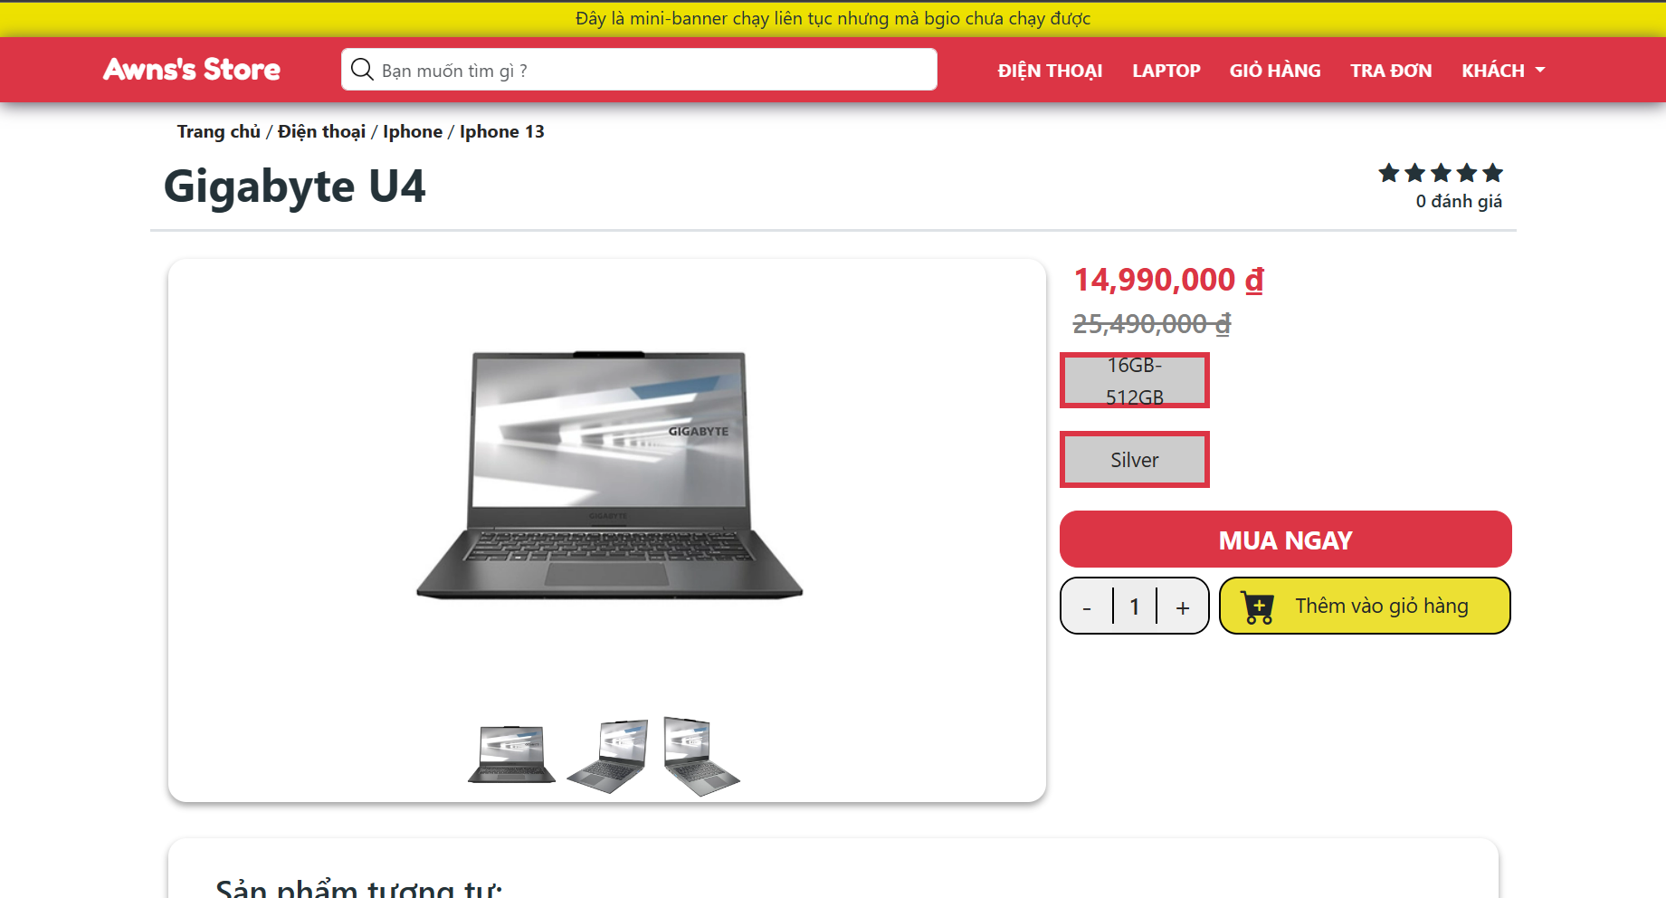

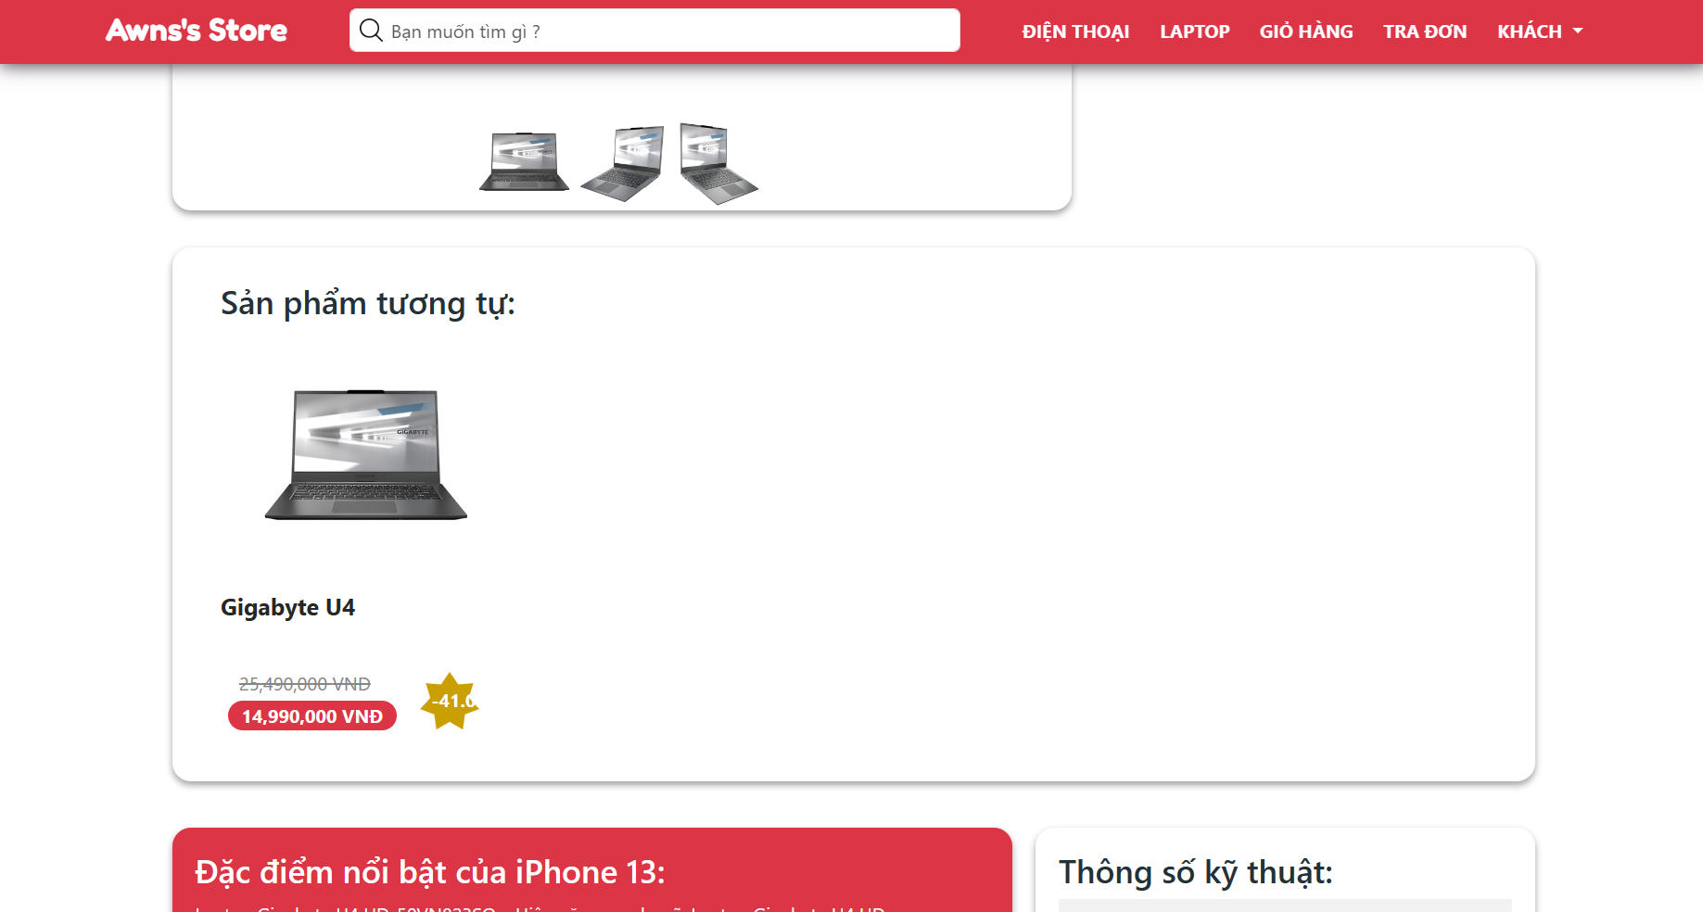

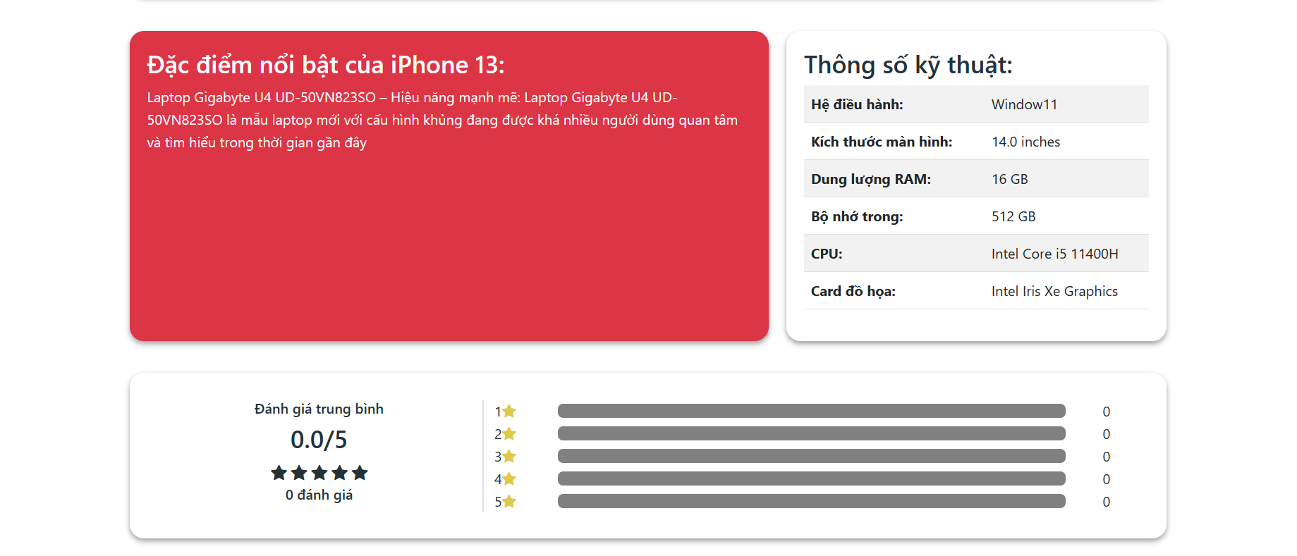

* Function Details:
  + Show product information with thumbnail, title, brief-info, reviews, product description and “Add to Cart” button.
  + Some related products.
  + Customers must choose the quantity and add to cart before buying. After clicking the “Thêm vào giỏ hàng” button, a popup shows up and customers can choose to continue shopping (the popup disappears) or go to their baskets.
  + After clicking the “Mua ngay” button, the product will be add to cart and the user will be navigated to My Cart screen

### d. Check the order

* Function trigger: This function will be triggered by a click on “Tra đơn” button on navigation bar
* Function description: The user can search order by order code
* Screen layout:

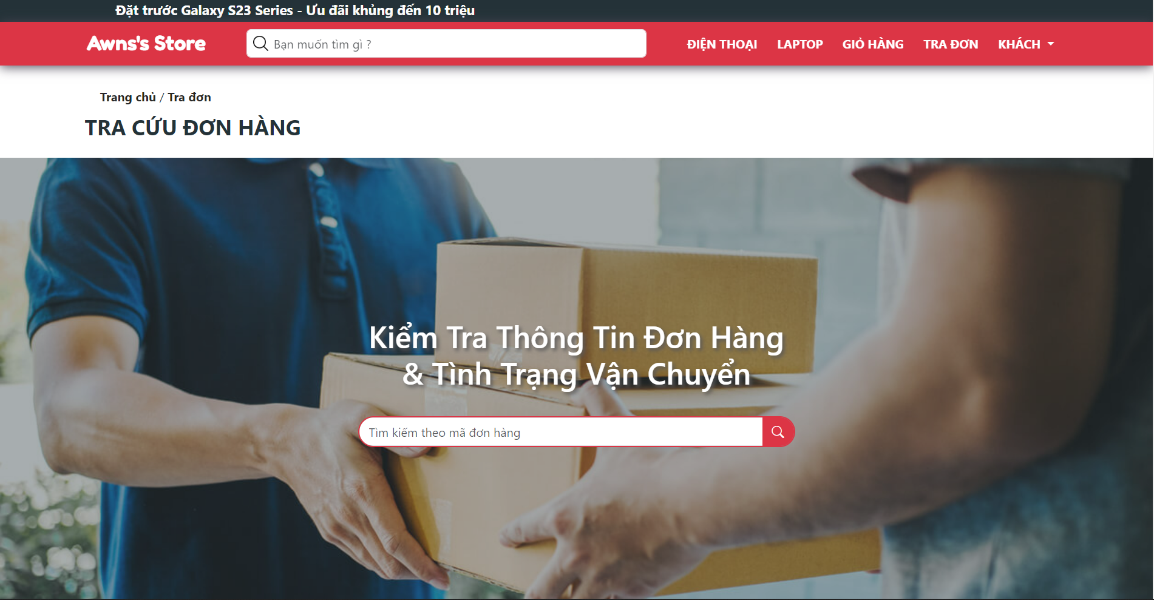

* Function Details: After fill order code on text box, the user click on the search icon to search the order, then user will be navigated to “Order Information” screen.

### e. My Cart

* Function trigger: This function will be triggered by a click on the “Giỏ hàng” button on navigation bar
* Function description: This screen show list of product on user’s cart
* Screen layout:

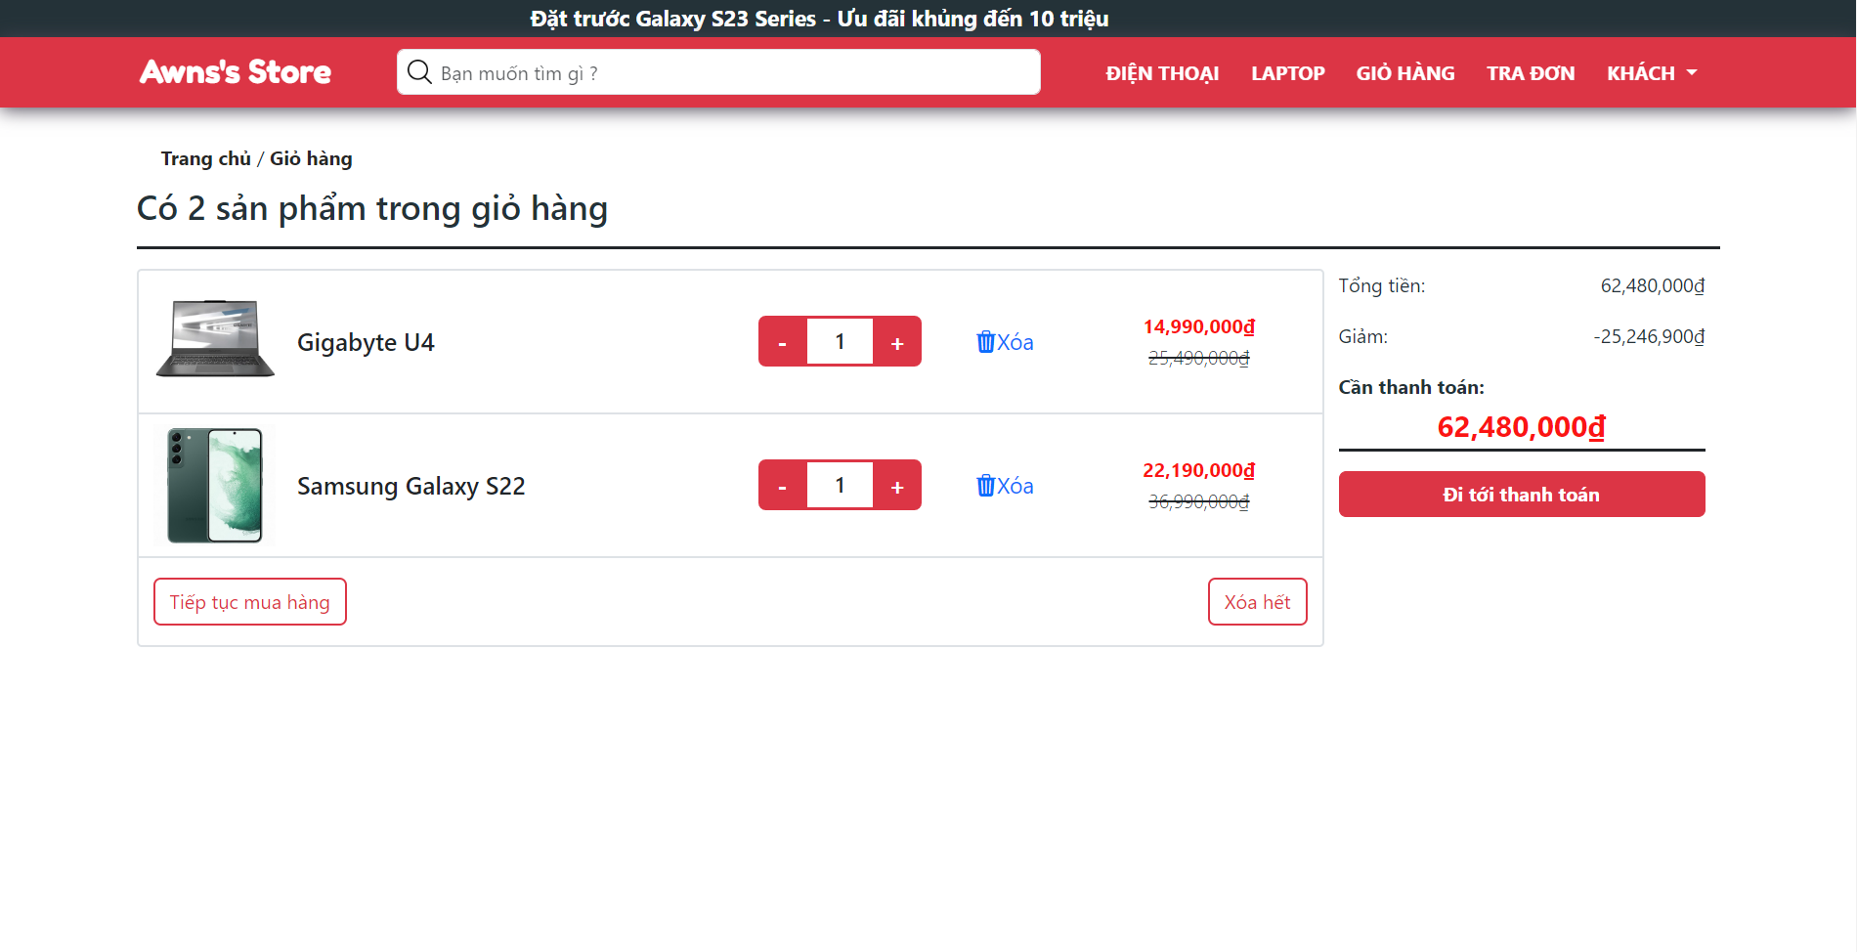

* Function Details:
  + All product on cart will be displayed
  + Click on the “Đi tới thanh toán” button to confirm payment

### f. Payment Page

* Function trigger: this function will be triggered by a click on the “Thanh toán” button on My Cart screen
* Function description: The user can view list of user’s chosen products and receiver information
* Screen layout:

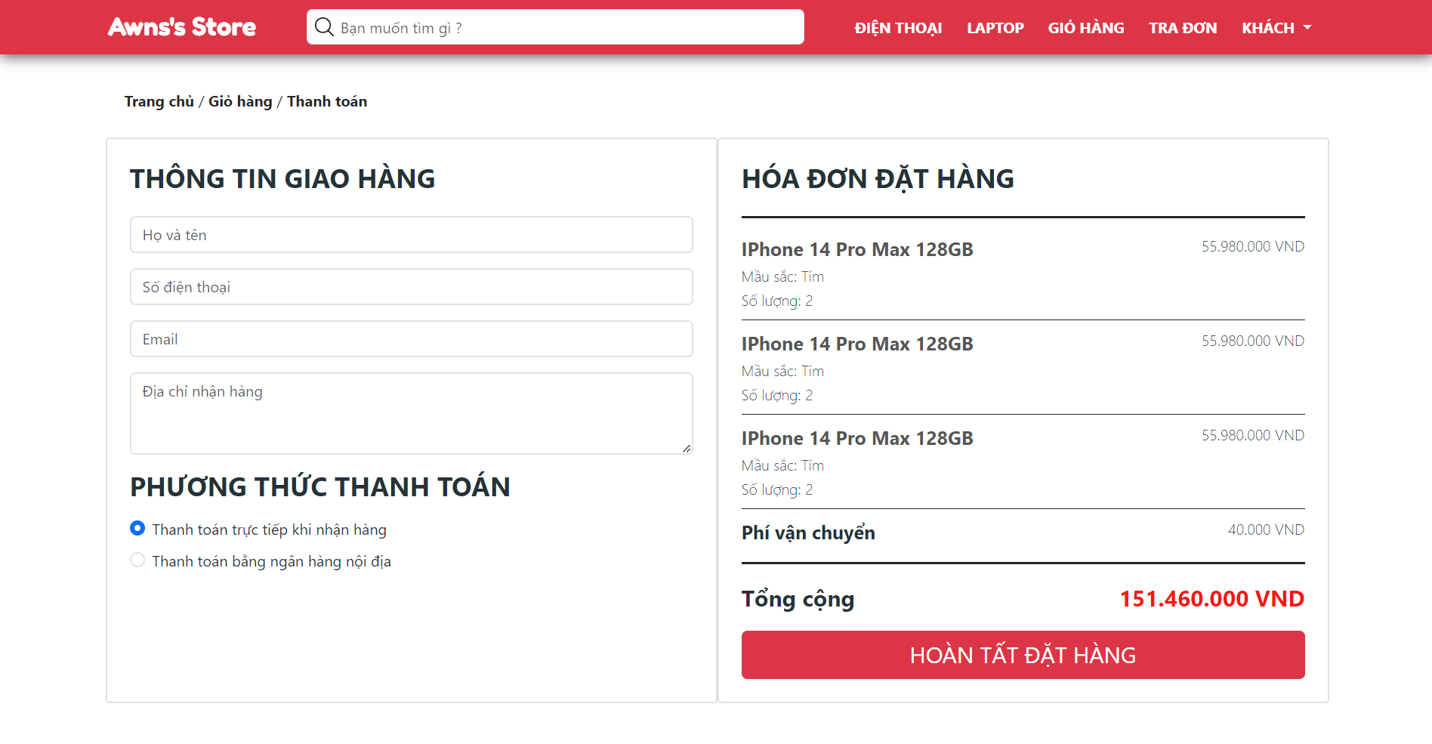

* Function Details:
  + All user’s chosen products and total cost will be displayed here
  + Guest user must be fill receiver information to go to check out, with customer (registered user) that information will be auto filled, customer also can edit them.
  + Click on the “Hoàn tất đặt hàng” to check out. After that, order information will be sent to email of user

## 2. Common Feature

### a. User Login

* Function trigger: This function is triggered when the user clicks “Khách” -> “Đăng Nhập” in the navigation bar
* Function description: The user logs in to the Online Shopping System
* Screen layout:

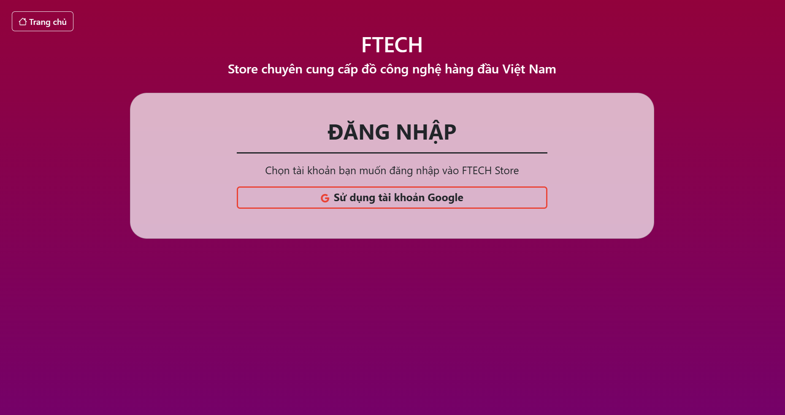

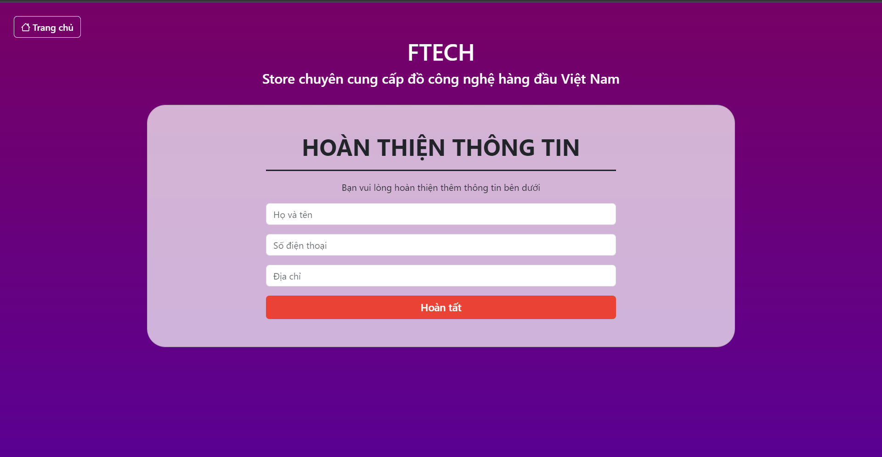

* Function Details:
  + When the user is in the state not logged in, at the home page there will be a “Khách” – “Đăng nhập” button, the “Đăng nhập” button will become the “Thông tin cá nhân” button after logged in.
  + By the first login, the user must be filled some information

### b. User Profile

* Function trigger: This function is triggered when the user clicks the “(Name of user)” – “Thông tin cá nhân” button in the navigation bar
* Function description: The user can view and update the profile information
* Screen layout:

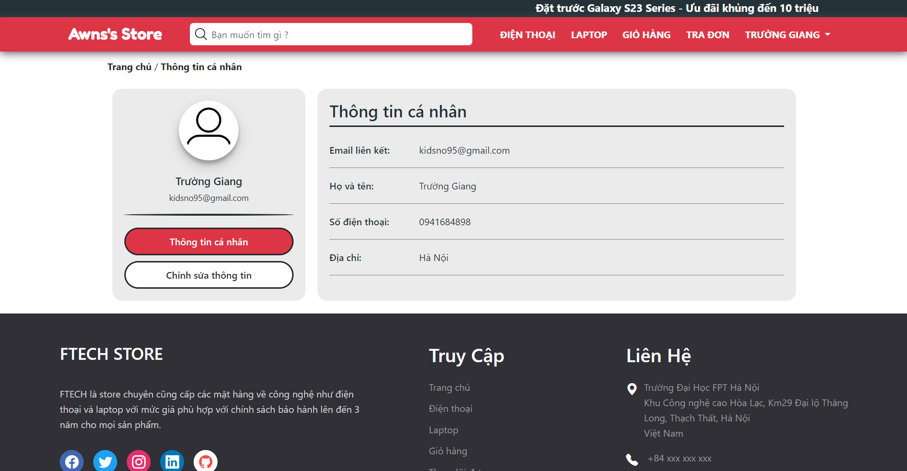

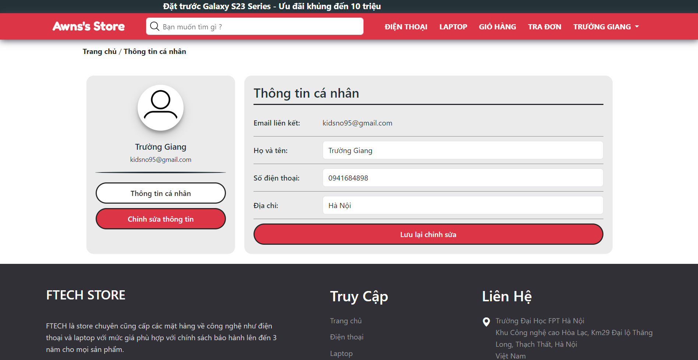

* Function Details:
  + All information of the user will be displayed here.
  + Click on the “Chỉnh sửa thông tin” button to update information, then click the “Lưu lại chỉnh sửa” button to save

### c. My Orders

* Function trigger: This function will be triggered by a click on the “(Name of user)” – “Đơn hàng của tôi” button
* Function description: The user views all him/her orders
* Screen layout:

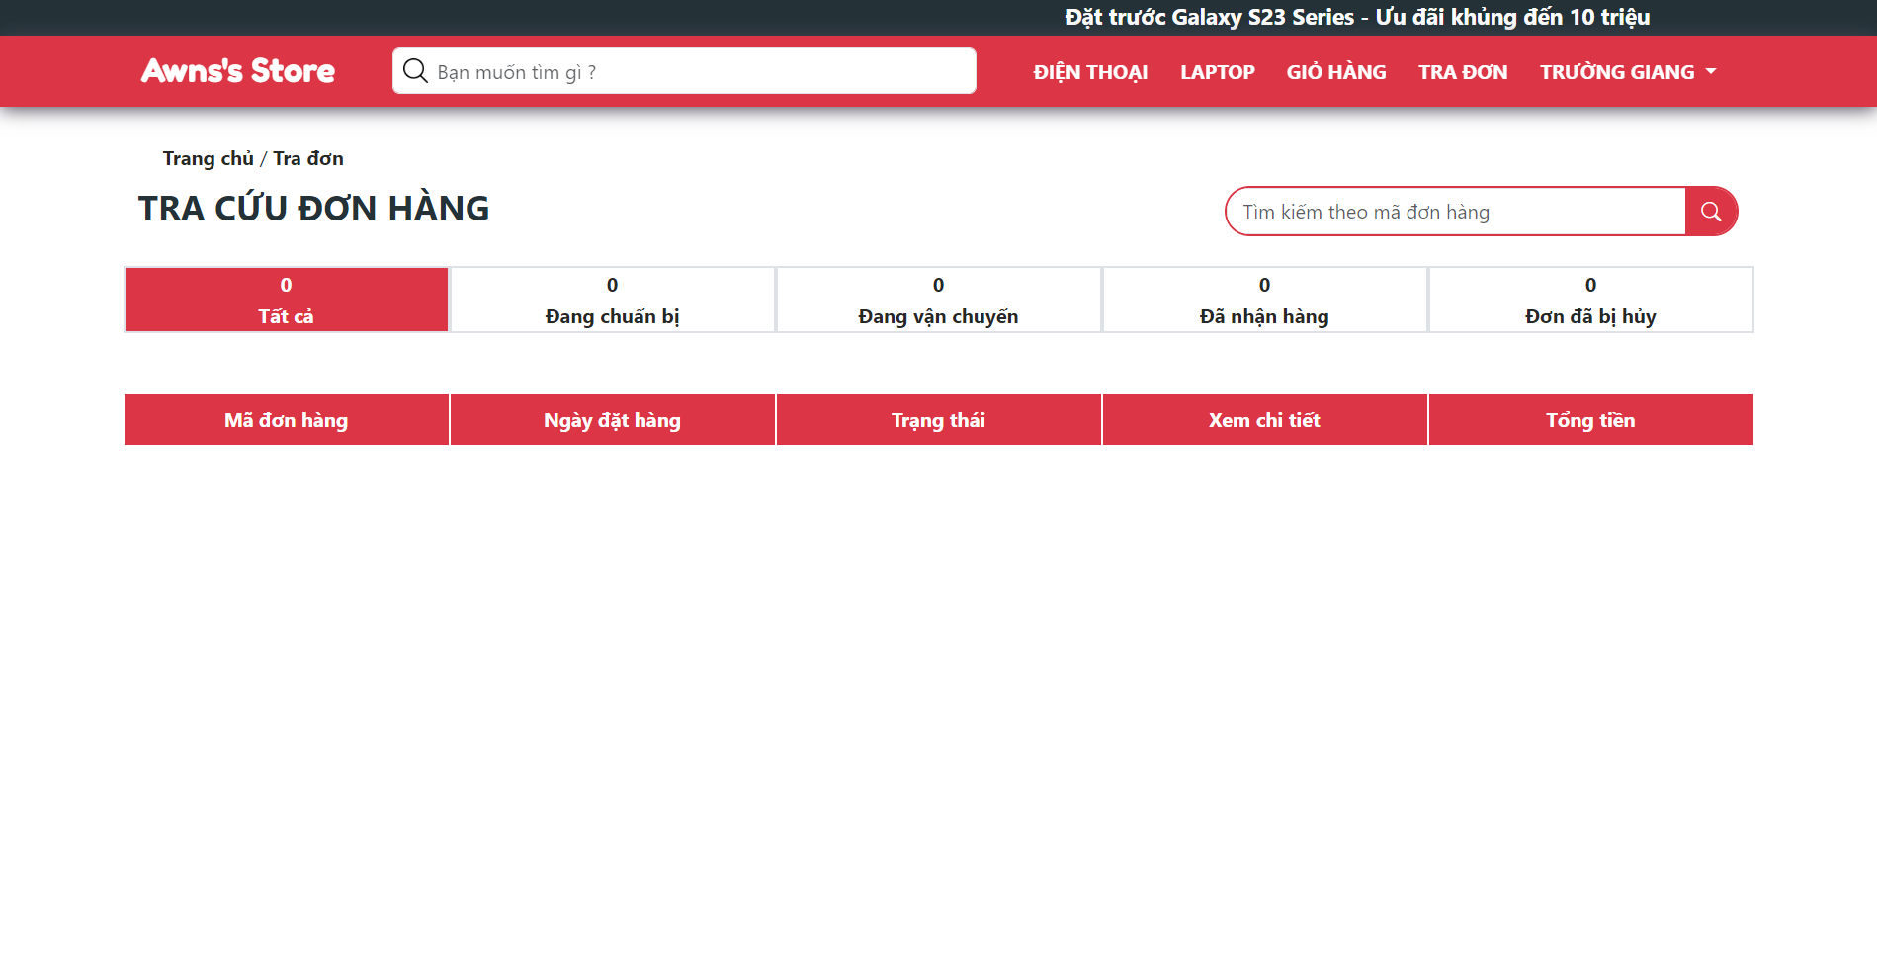

* Function Details:
  + All him/her orders will be displayed here and orders are classify by order status
  + Click on the “Xem chi tiết” button to view order information

### d. Order Information

* Function trigger: This function will be triggered by user click on the “Xem chi tiết” button in “Đơn hàng của tôi” screen or fill order code and click on the search icon in “Tra đơn” screen
* Function description: The user can view order details
* Screen layout:

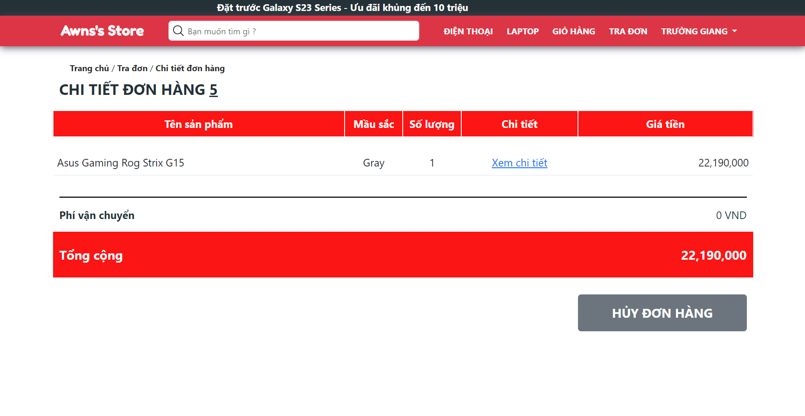

* Function Details:
  + All information about order will be displayed here
  + If order status is “Đang chuẩn bị”, user can click on the “Hủy đơn hàng” button to cancel this order

### e. Employee Login

* Function trigger: This function will be triggered by a click on the “Đăng nhập cho nhân viên” button
* Function description: The employee input username and password to login system
* Screen layout:

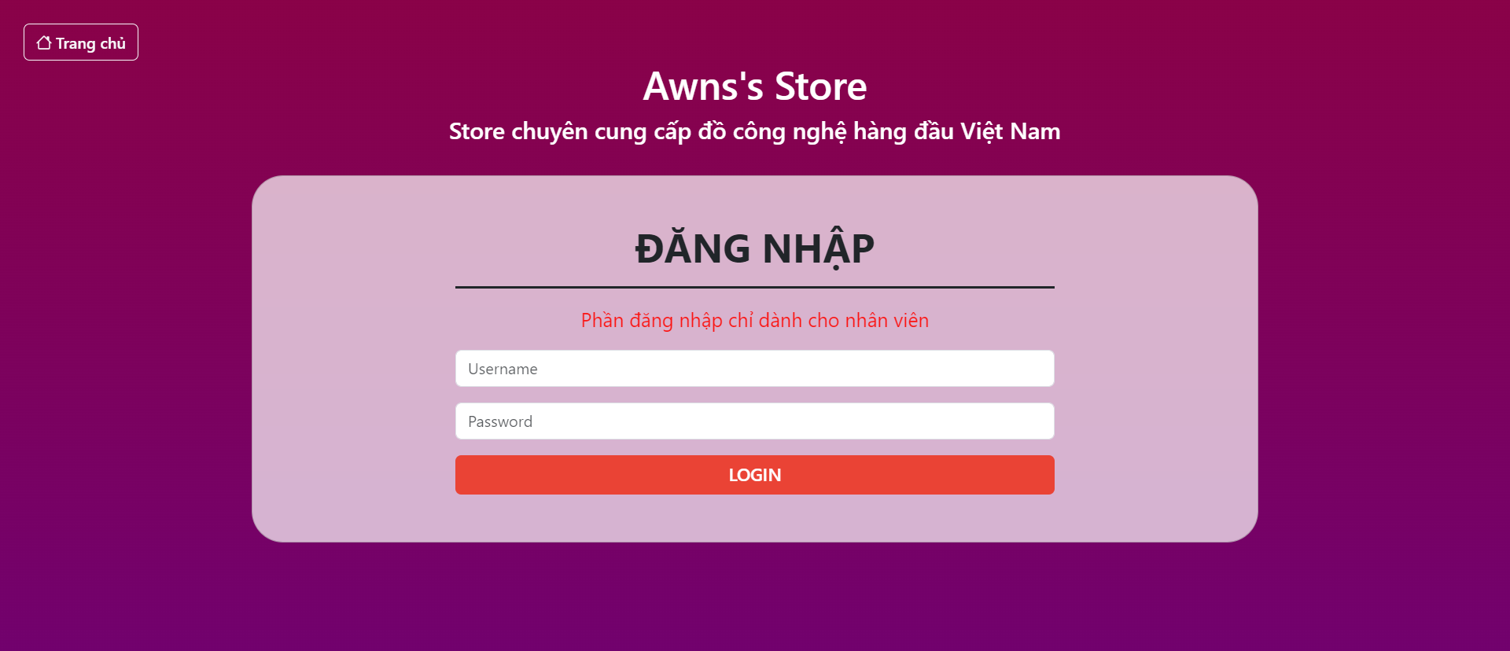

* Function Details:
  + The employee input username and password, then click on “login” button to login in system
  + The employee will be navigated to his/her role dashboard

## 3. Admin Feature

### a. Admin Dashboard

* Function trigger: This function will be triggered after admin login in to system
* Function description: This screen shows related – management data, revenue)
* Screen layout:

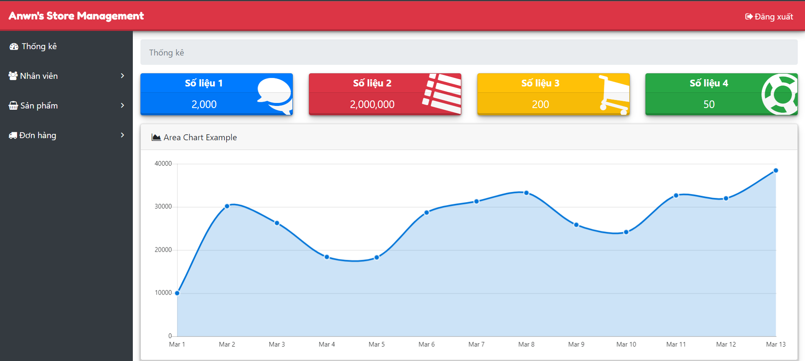

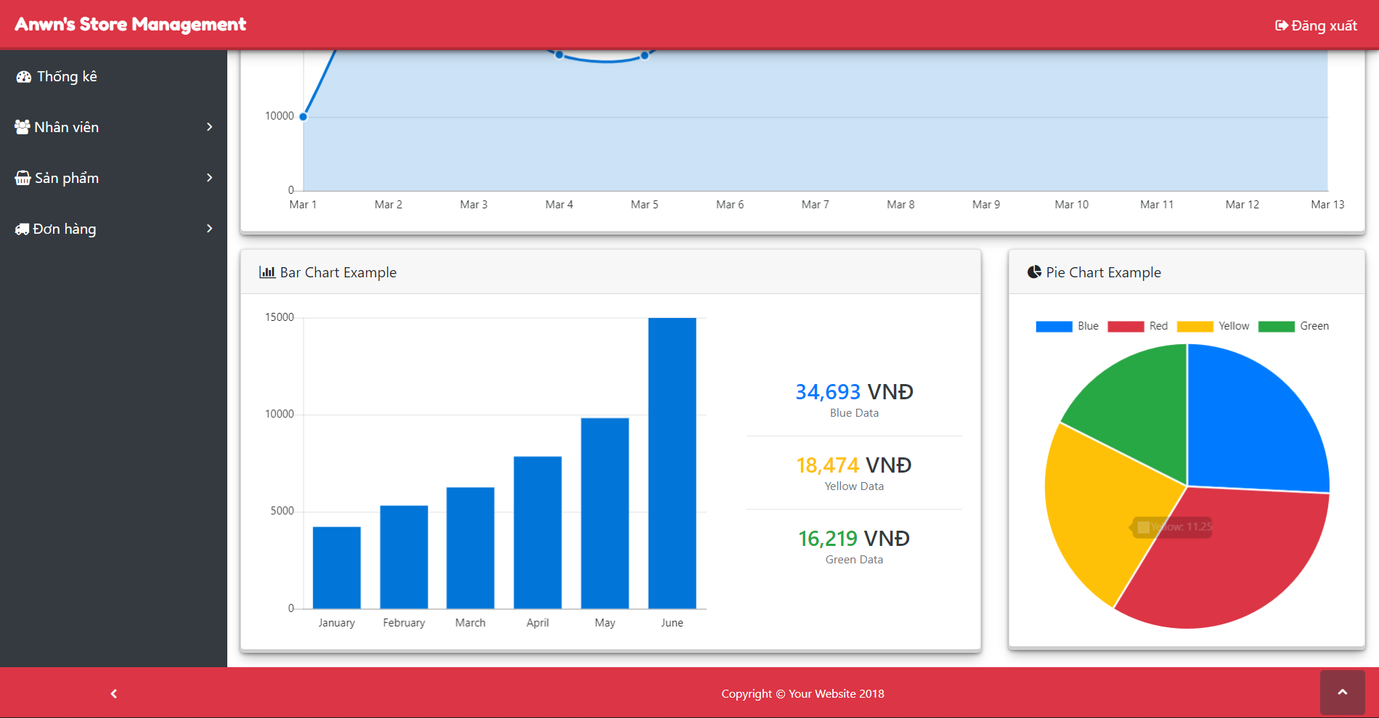

* Function Details:
  + This screen show chart to statistic revenue of 30days/month/year

### b. Employee Management

* Function trigger: This function will be triggered after click on “Nhân viên” – “Quản lý nhân viên” button on admin dashboard
* Function description: This screen list of employees (sale, warehouse)
* Screen layout:

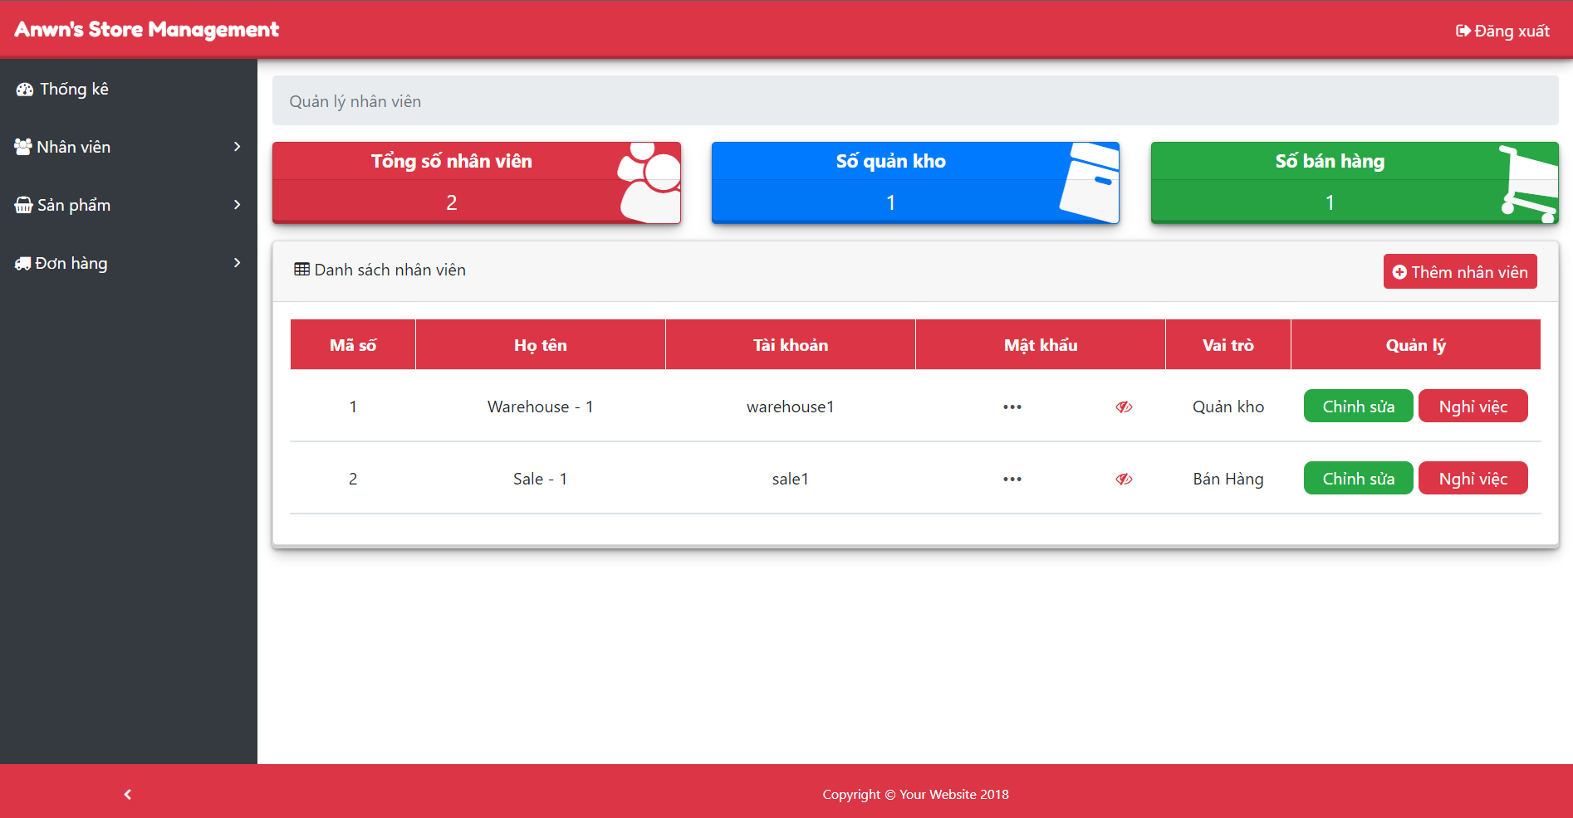

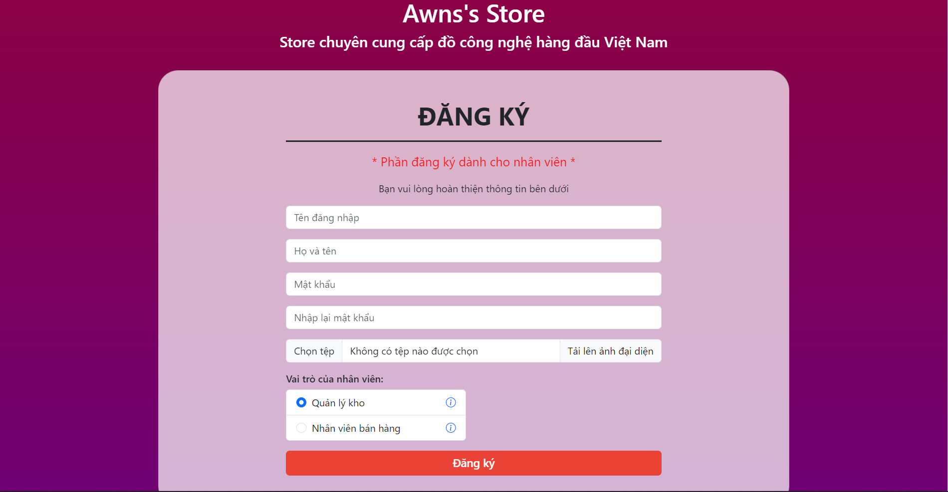

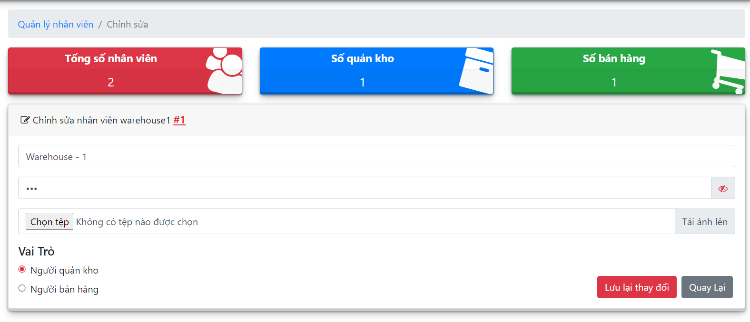

* Function Details:
  + This screen show list of employees (sale, warehouse) of system
  + The admin can and new employee account, edit employee information or delete employee account
  + After click on “Thêm nhân viên” button, the admin will be navigated to register employee screen. After fill information, click on “Đăng ký” button to create new employee account
  + After click on “Chỉnh sửa’ button, the admin will be navigated to edit information employee screen, after edit information, click on “Lưu lại thay đổi” to save or click on “Quay lại” button to cancel and return to employee management screen

## 4. Warehouse Feature

### a. Warehouse Dashboard

### b. Warehouse Management

## 5. Sale Feature

### a. Sale Dashboard

### b. Product Information Management

* Function trigger: This function will be triggered after click on “Sản phẩm” – “Quản lý sản phẩm” button on sale dashboard
* Function description: This screen shows list of products
* Screen layout:

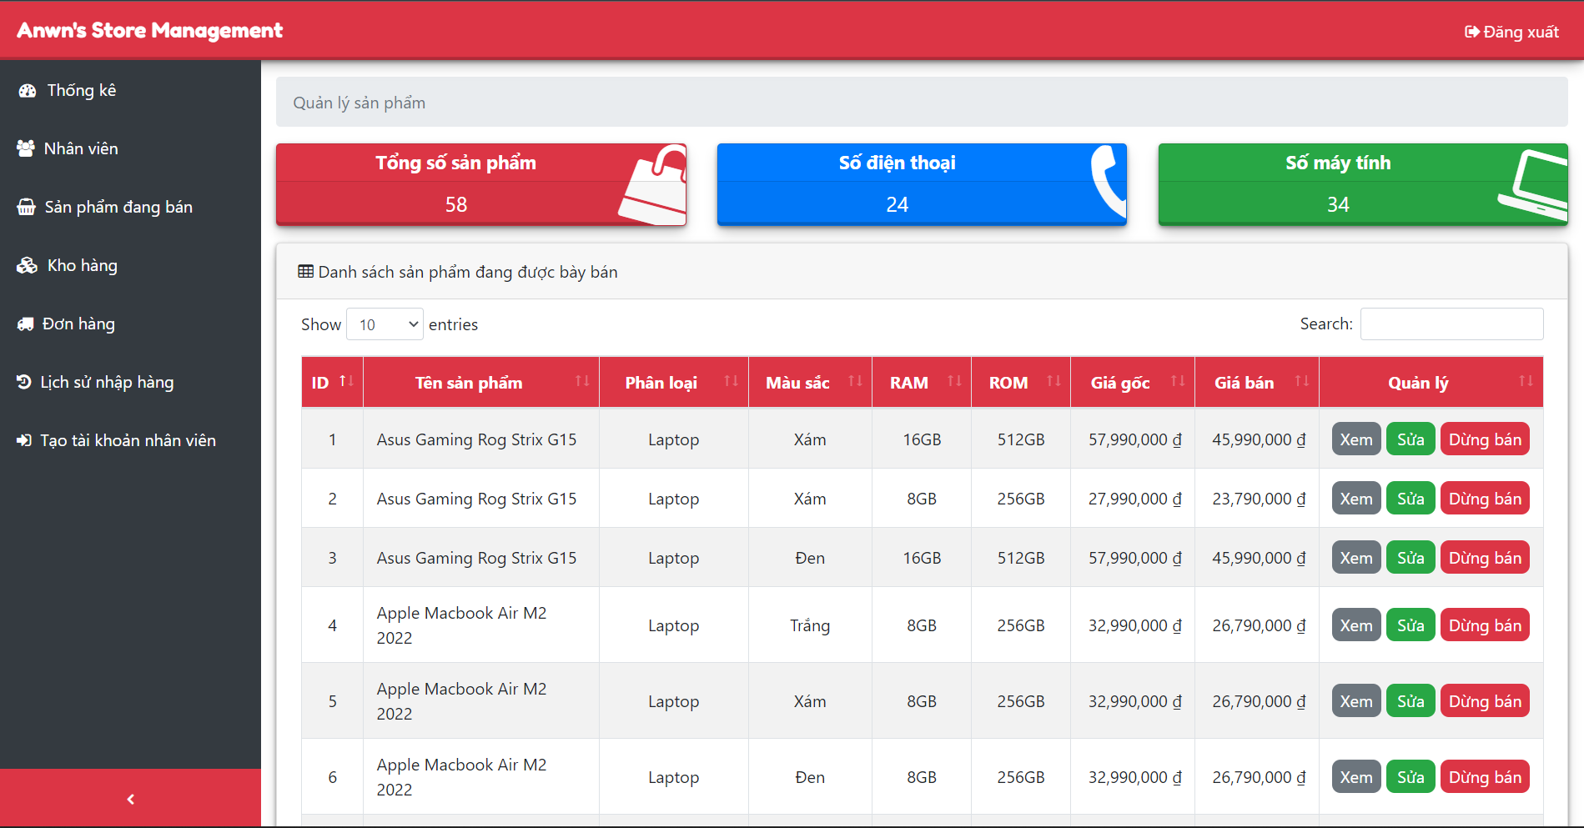

* Function Details:
  + This screen show list of products and details information
  + The sale can view, update information of product or change product selling status (selling/stopped selling)